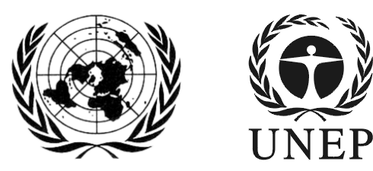 | SAICM/ICCM.5/Bureau.2/9
 |  | Distr.: General  2 December 2016  English only
Second meeting of the Bureau of the
International Conference on Chemicals Management for its fifth session
Sao Paulo, Brazil
7-8 December 2016
Item 6 (a) of the provisional agenda*
Implementation towards the achievement of the 2020 goal: Update on implementation of the Overall Orientation and Guidance

Tracking implementation of the SAICM Overall Orientation and Guidance for achieving the 2020 goal
Note by the secretariat
- At its first meeting the ICCM5 Bureau requested the SAICM secretariat to invite the regions and SAICM stakeholder groups to compile information on initiatives related to the implementation of the SAICM Overall Orientation and Guidance within their respective regions and areas through a set of tracking tables.
- The purpose of this exercise is to gather the necessary information that will help guide the SAICM secretariat in supporting the SAICM national focal points in undertaking the action points set out in the Overall Orientation and Guidance. The collection of information is also intended to assist in reporting on SAICM implementation.
- The secretariat sent the invitation to complete the tables on 6 May 2016 for submission by 14 October 2016.
- To date, submissions have been received from the following groups:
  - Regions: Africa, European Union;
  - Countries: Barbados, Brazil, Canada, Colombia, Costa Rica, Mexico, Monaco, Panama;
  - Non-governmental: Industry, International POPs Elimination Network, the Pesticides Action Network;
  - United Nations organizations coordinated by the IOMC.
- The secretariat has made the submissions available to meeting participants.
- The Bureau may wish to provide guidance to the secretariat on next steps.

___________________

*SAICM/ICCM.5/Bureau.2/1

